INTRODUCTION

A Railway Reservation System is a digital solution designed to facilitate the booking of train tickets. It provides users with a user-friendly interface to check train schedules, seat availability, and make reservations online. The system typically includes features such as a search functionality to find trains, information on available seats and classes, and secure online payment options.

Passengers can browse through different trains, select their preferred travel date and class, and then proceed to book tickets seamlessly. The system also often includes functionalities like cancellations, seat upgrades, and viewing booking history.

Overall, the system streamlines the entire process of train ticket booking, making it more efficient and convenient for both passengers and railway authorities.

PURPOSE OF THIS PROJECT

The purpose of a Railway Reservation System project is to create a digital platform that simplifies and automates the process of booking train tickets. This system aims to provide a convenient and efficient means for passengers to plan and reserve their train journeys. The key objectives include:

* Ease of Booking: To enable users to easily check train schedules, seat availability, and book tickets from the comfort of their homes or any location with internet access.
* Accessibility: To make train ticket reservations accessible to a broader audience, including those who may face challenges with physical ticketing counters or manual booking processes.
* User-Friendly Interface: To provide a simple and intuitive interface for users, making the booking process straightforward and easy to understand.
* Accuracy: To ensure accurate and up-to-date information about train schedules, seat availability, and passenger details, minimizing errors in the booking process.

Implementation Details

Classes and Interfaces

Train Class

The 'Train' class represents a train entity and holds details such as the train name, total seats, and available seats.

SeatNotAvailableException

The 'SeatNotAvailableException' class is an exception handler specifically designed to manage seat reservation errors.

ReservationSystem Interface

This interface, 'ReservationSystem,' defines the essential methods required for the proper functioning of the reservation system.

RailwayReservation Class

The 'RailwayReservation' class implements the 'ReservationSystem' interface and provides the main functionalities of the railway reservation system.

Main Class

The 'Main' class acts as the entry point for the application, allowing users to interact with the reservation system through a menu-based interface.

Functionality

The system boasts a range of functionalities, including the display of available trains with seat information, booking and cancelation of tickets, and the option to show a list of passengers for a specific train.

Exception Handling

The system incorporates robust exception handling to manage scenarios where seats are not available during the booking process, ensuring a smooth and error-free user experience.

Usage

To use the application, execute the 'Main' class, which serves as the primary entry point. Users can then choose from various menu options to perform different operations.

Future Enhancements

The project lays the groundwork for potential future enhancements, such as the addition of user authentication and authorization, implementation of a graphical user with a database for persistent data storage.

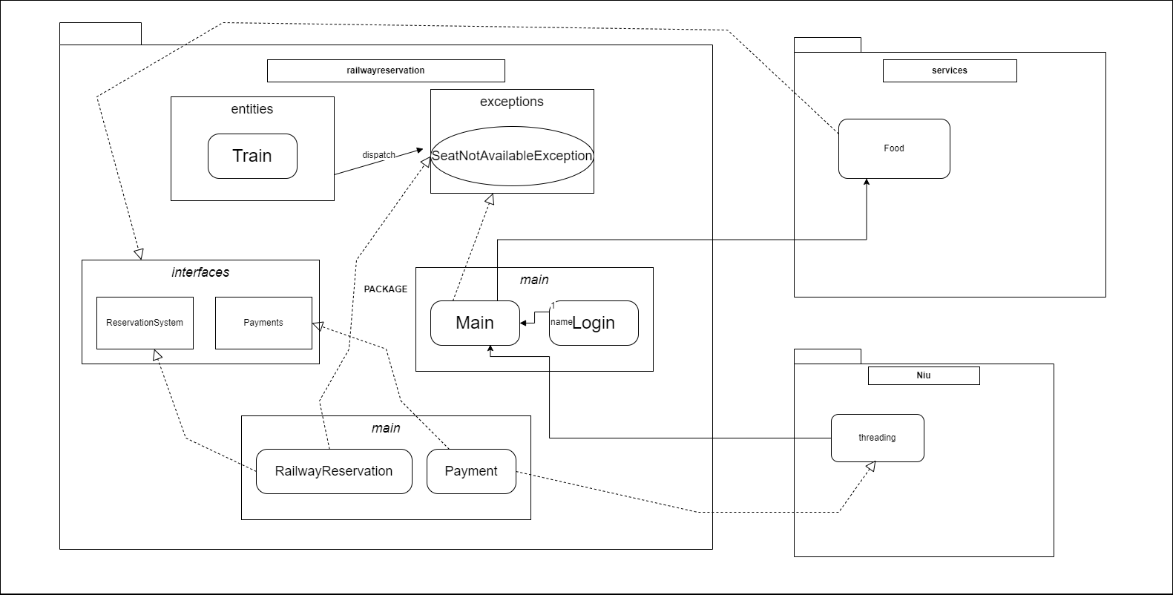Project Structure

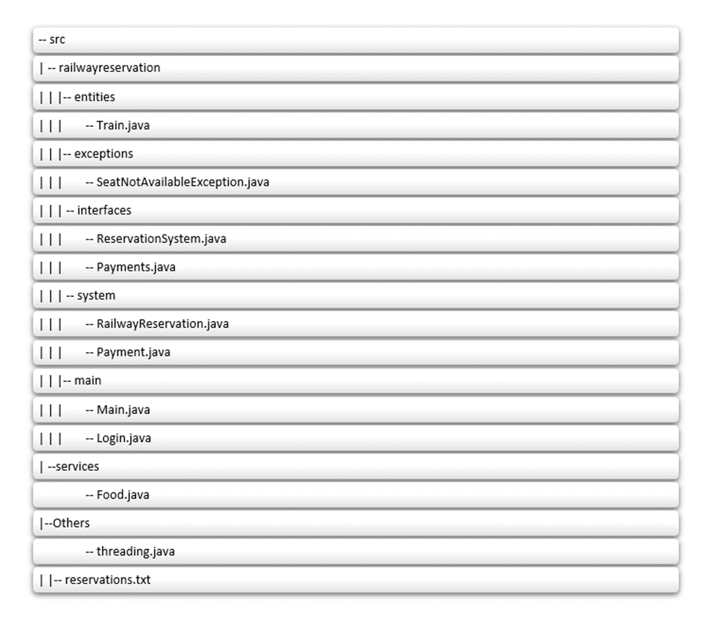Project Tree

Functionalities of Project Code

The RailwayReservation package contains these classes:

* Train Class:

This class manages and provides information about train schedules, including departure and arrival, available seats and routes.

* SeatNotAvailableException Class:

The SeatNotAvailableException class throws a custom exception if the requested seats are not available at the moment.

* RailwayReservation Class: The RailwayReservation class serves as the core component in the railway reservation system project, orchestrating the various functionalities required for users to book train tickets. This class acts as a bridge between different modules and ensures a seamless booking experience.
* Payment Class:

The Payment class within the railway reservation system project is responsible for handling all aspects related to financial transactions during the ticket booking process. This class facilitates secure and seamless online payments, ensuring a reliable and user-friendly experience for passengers.

The service package contains food class :

* Food Class : The Food class in the railway reservation system project is responsible for managing and facilitating food-related services for passengers during their train journeys. This class enhances the overall travel experience by allowing users to pre-order or purchase food items while on board.

Purpose and Features:

Modularity and Encapsulation:

The project is designed to showcase the principles of modularity and encapsulation. Each package encapsulates related functionality, providing a clear boundary between different aspects of the system.

Code Reusability:

By organizing code into packages, classes within each package can be reused in other projects with minimal effort. This promotes a more efficient and scalable development process.

Maintainability:

The modular structure enhances code maintainability. Changes or updates to a specific functionality can be made within the confines of a package without affecting unrelated parts of the codebase.

Future Scalability

This project is scalable by implementing multiple classes mentioned in notInUse Package.

We have added classes like :

* Destination class
* ModifyTicket
* Postpone Date
* Refund